After creating eks cluster:

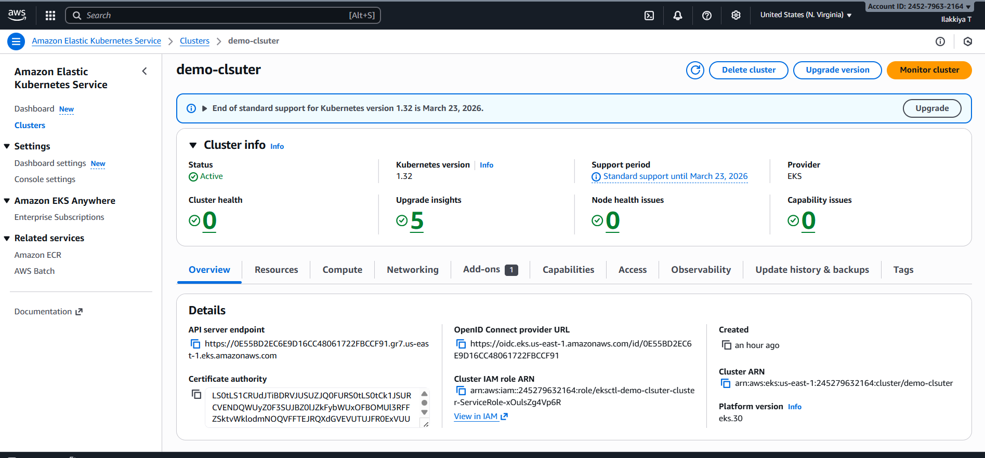

After deploying Loadbalancer

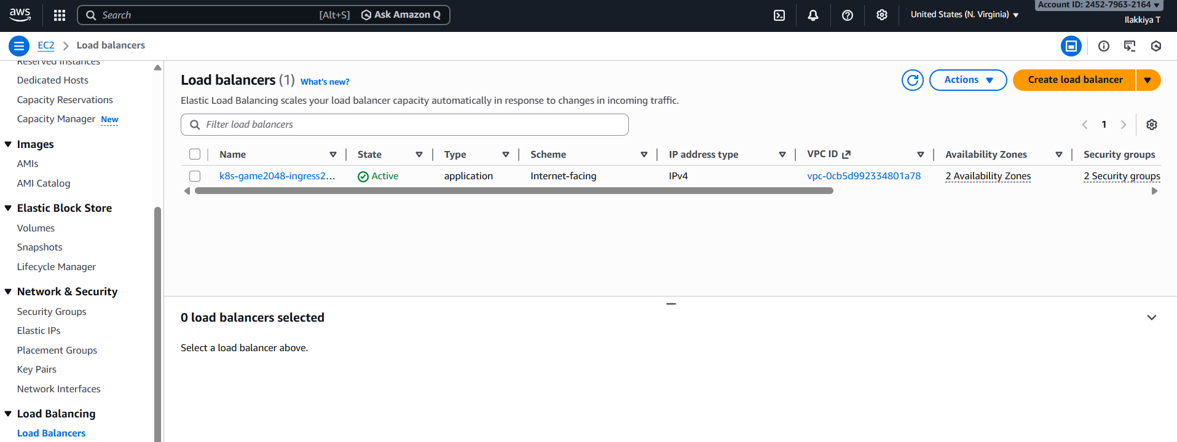

Application reachable via Loadbalancer Url

http://aws-prod-example-663632714.us-east-1.elb.amazonaws.com

